We're in one of the longest periods of US Small Cap underperformance.
History indicates a long period of strong outperformance typically follows, see red arrow.
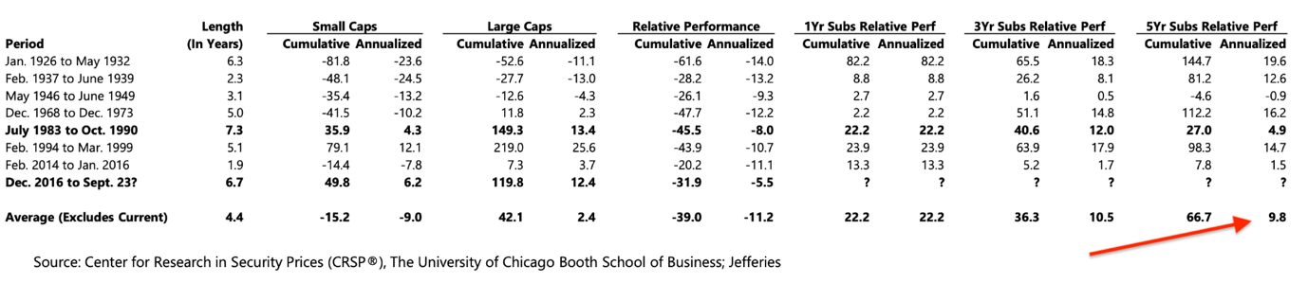
​​​​​​

Investors are starting to chase a mean reversion now that Large Cap Growth versus Small Cap Growth performance has reached extreme levels
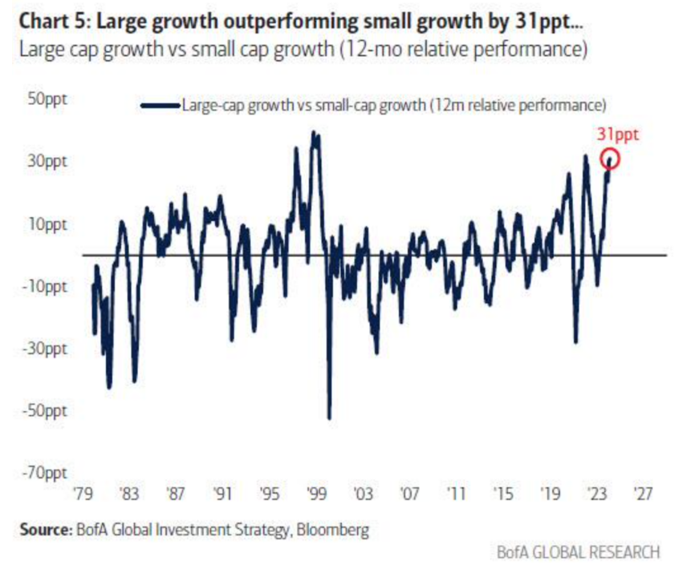

Cumulative flows (in millions of dollars) for Small Cap Growth pick up
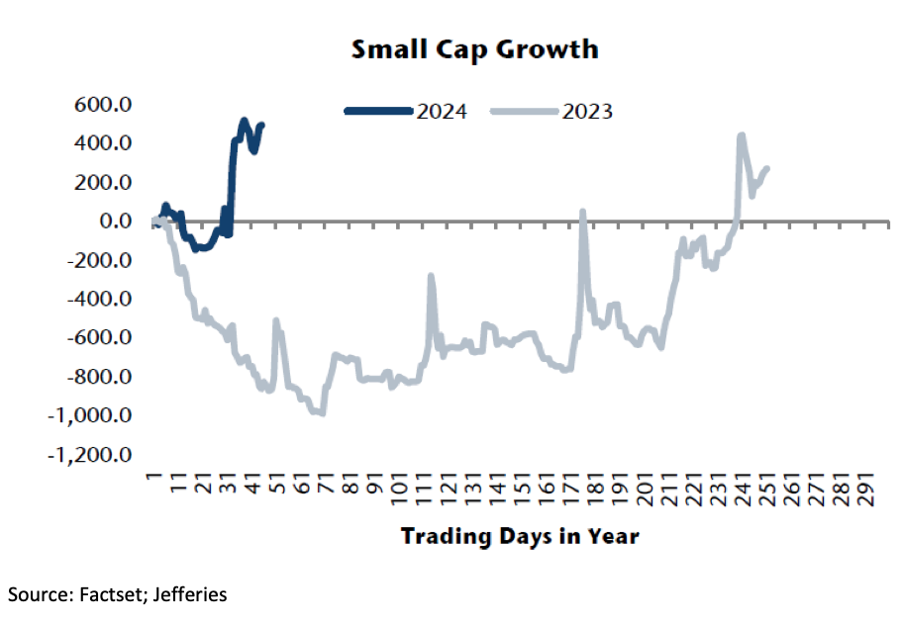

Performance after first Fed interest rate cut​​
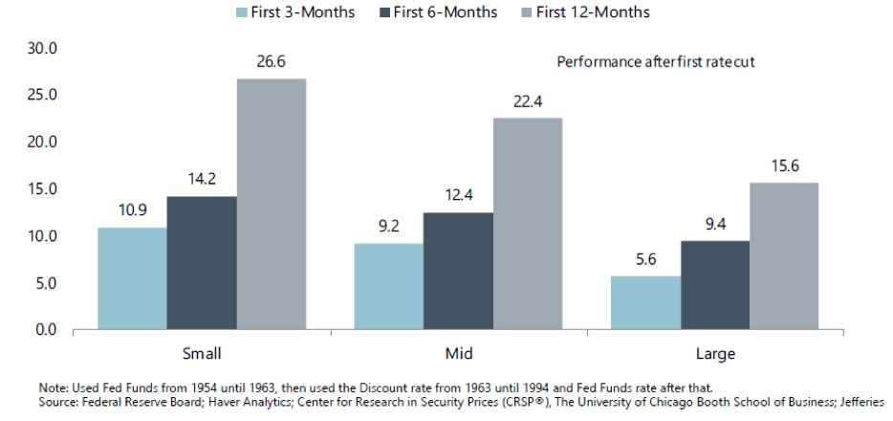

If the public markets don't re-rate Small Cap Stocks,..then the Private markets surely will!
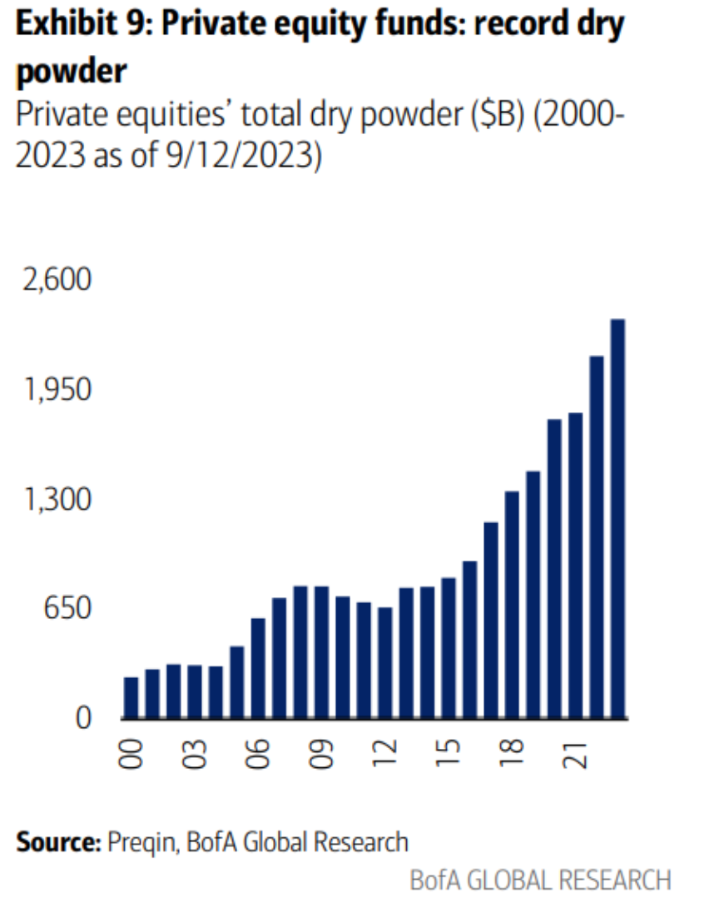

US Small Cap forward P/E is below long term averages and well below that of US Large Cap Equities
Historically this is the other way round.
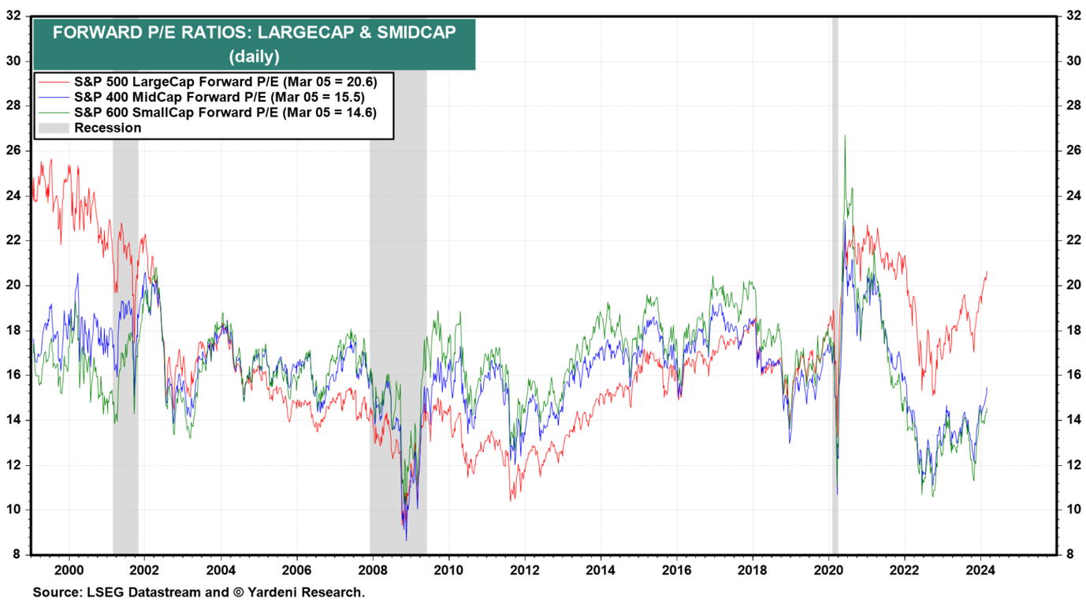

Relative Valuation and Relative Performance of Russell 2000 vs Russell 1000
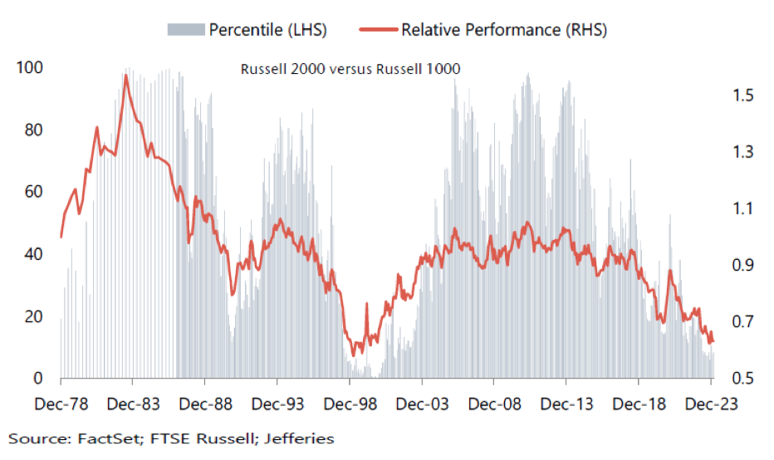

Performance across CPI environments
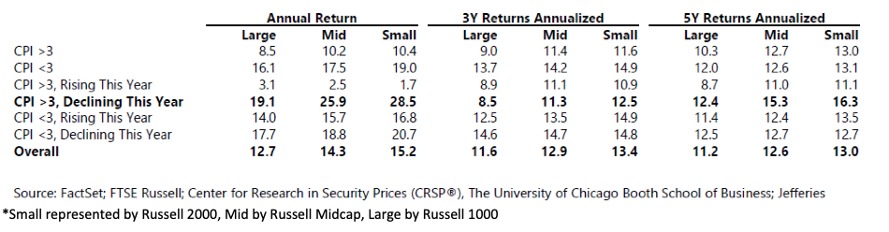

10y return US Large Cap (R1000) versus US Small Cap (R2000)
Large Caps outperformed Small Caps with > 100%.
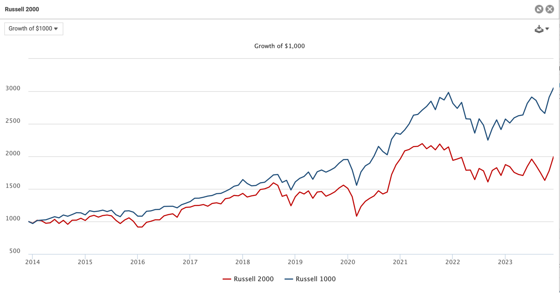

Relative Forward P/E Russell 2000 vs Russell 1000 - 1985-31-10-2023
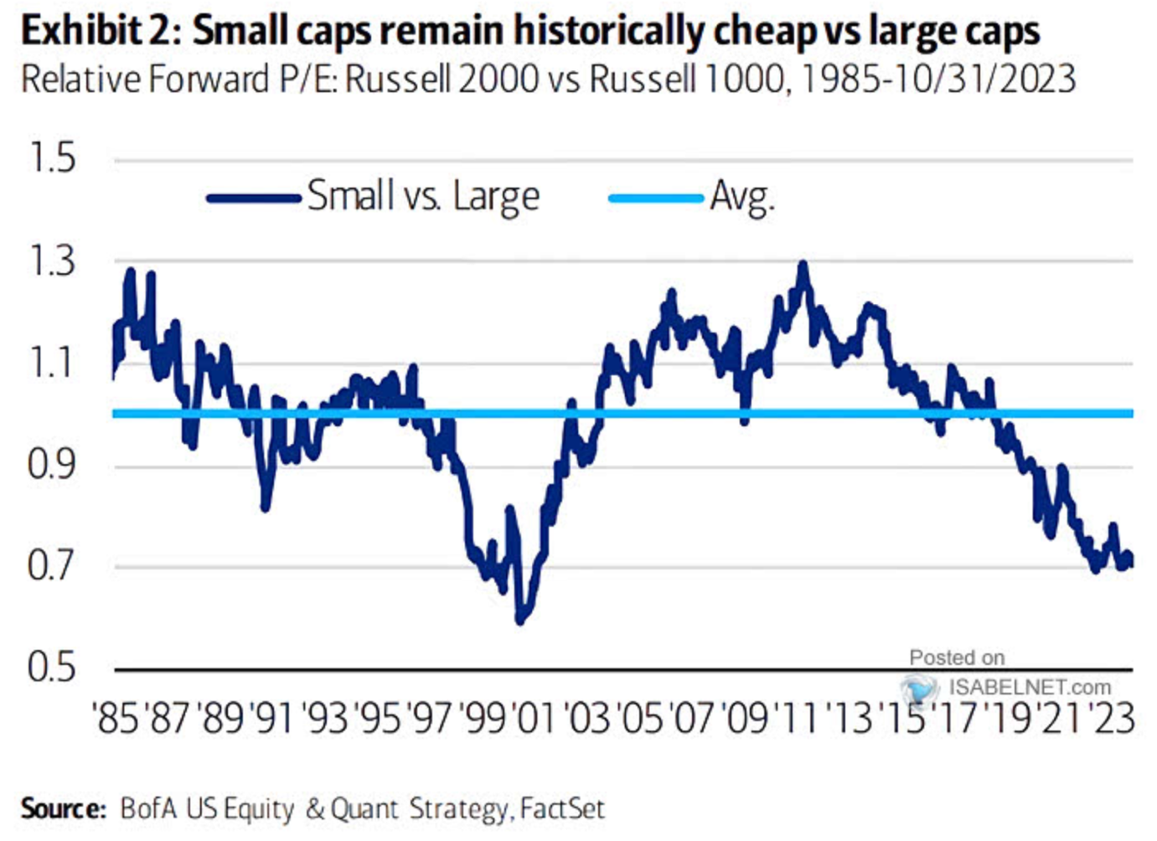

Small Caps/ Nasdaq
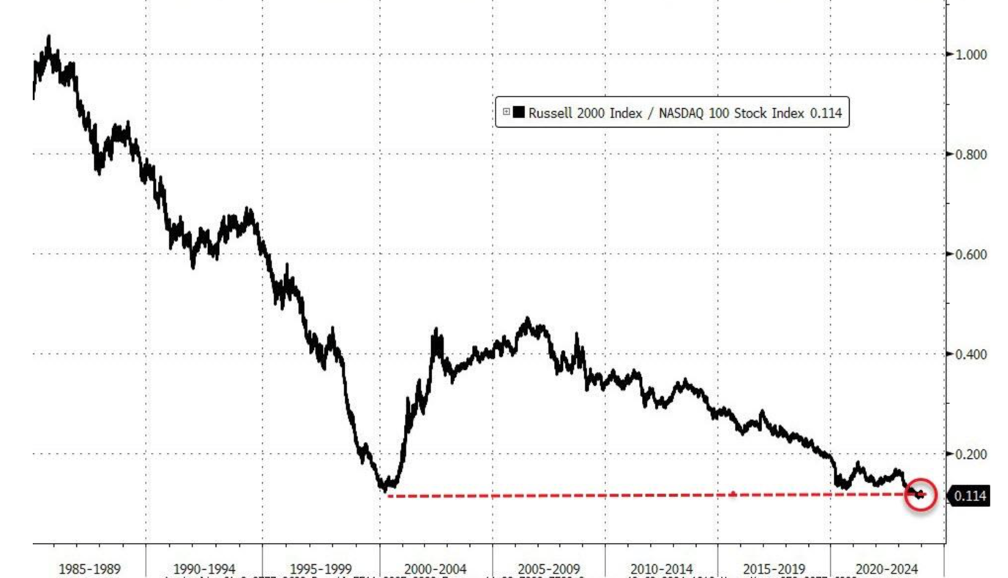
Last time valuation of Nasdaq versus Small Cap Value got this extreme, this is what happened next...
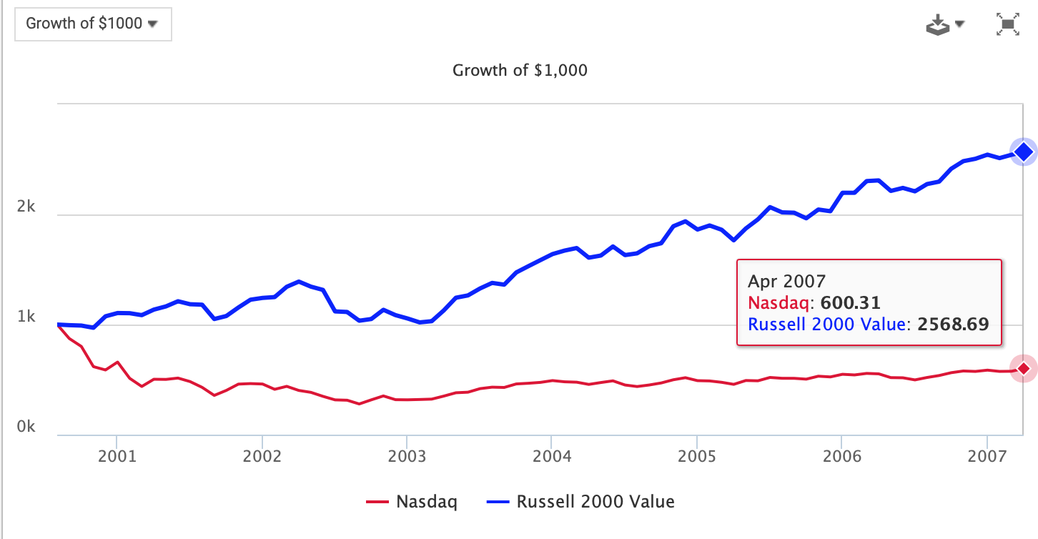
Nasdaq down 40%, Small value up 157%, despite rising rates from 2005-2007

Performance in weaker USD environment
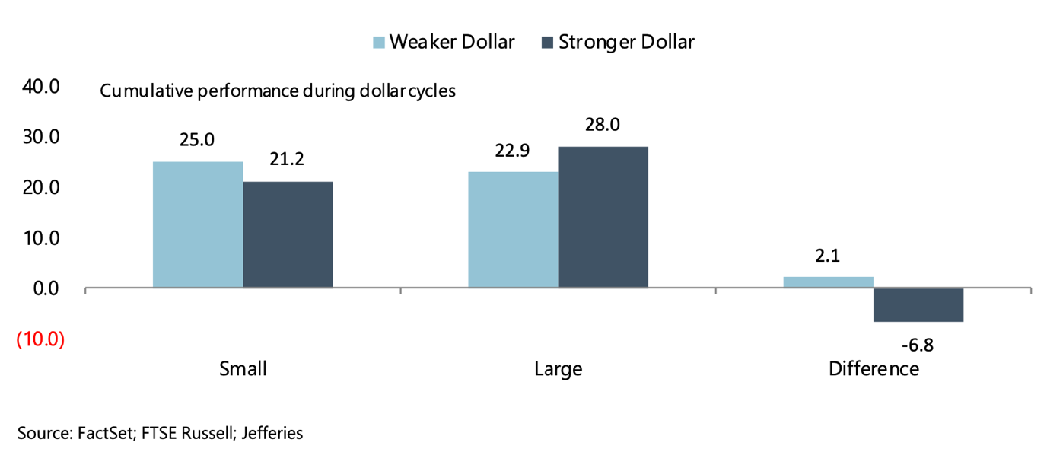

Small Cap Performance Around Recessions (last 6 recessions since 1980)
​​​​​
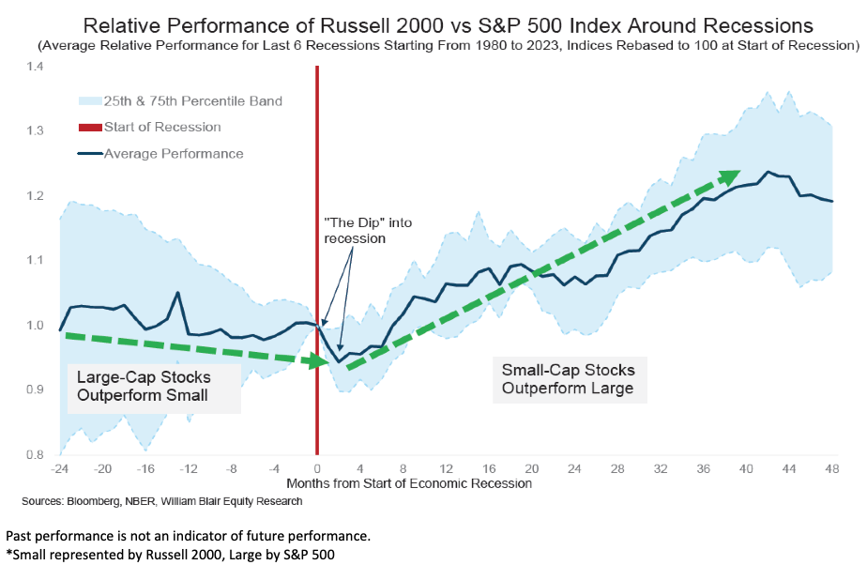

Other related charts:
Expected returns next decade for Magnificent 7 do not look good at all.
Time to sell those and buy things that are cheap?
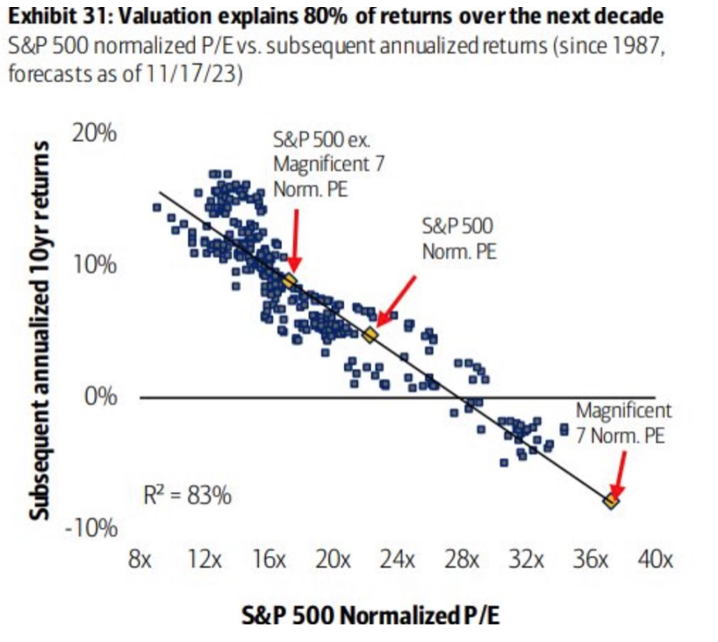

Small Caps have pushed out financing needs, but are typically financed shorter term- have a higher rate sensitivity
One of the reasons small caps tend to do well in FED easing periods
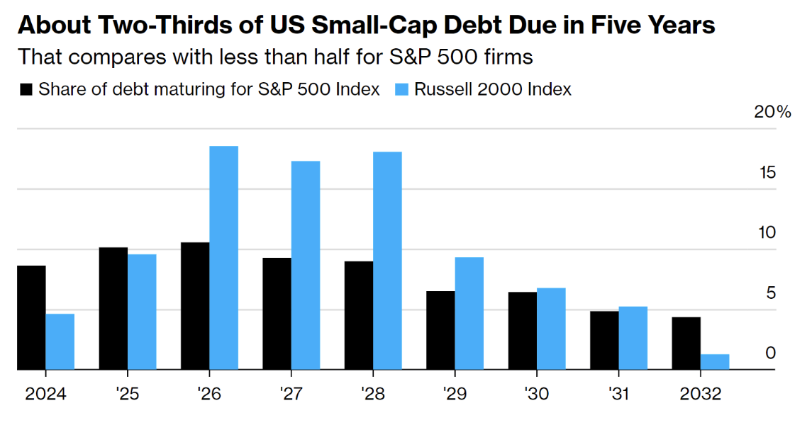

Sales per employee in US Small Caps hit record highs..
​​​​​​
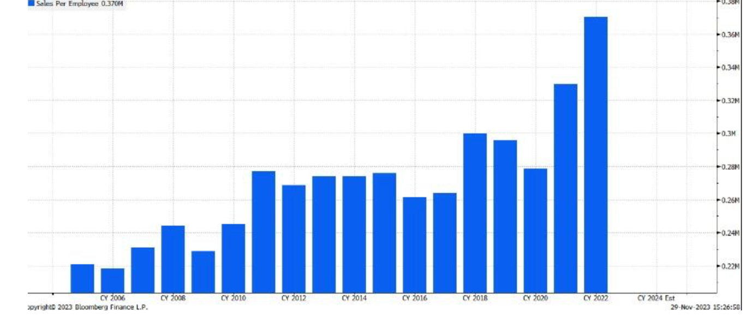

Allocate to active!
Almost all active managers beat the Small Cap Benchmark ( red square) longer term (22 year chart)
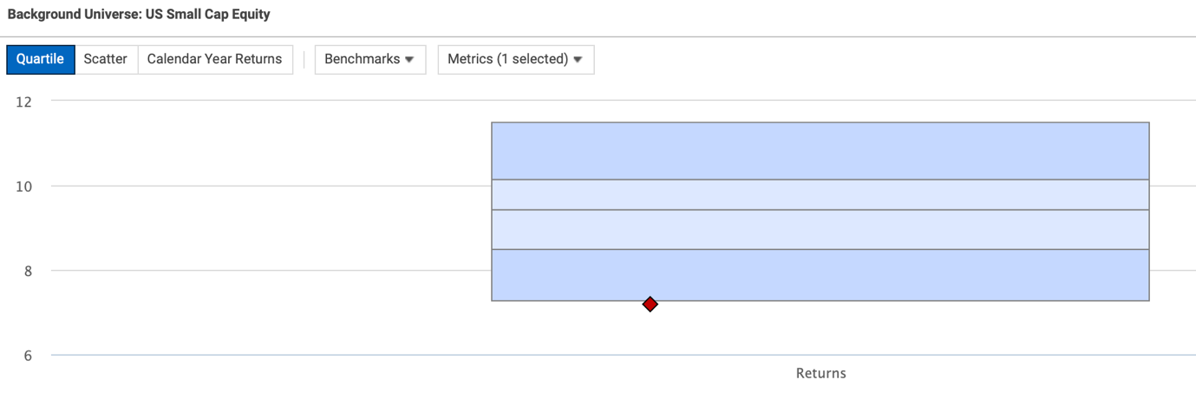

Next Century Growth US Small Cap Growth Equities
The Next Century Growth (NCG) US Small Cap Growth Strategy is a high conviction, high alpha generating strategy that seeks to invest in the fastest growing and highest quality small cap companies in America. A daily liquid Art. 8 UCITS fund with an AUM of USD 61 million is available. ISIN code: IE000TY23GV5
As per Q4, 2023 the Next Century Growth US Small Cap Growth Equity Strategy has an annualised outperformance of 5.01% over the Russell 2000 Growth index, outperforming 83% of peers according to eVestment since inception in 1999. Next Century Growth is an independent investment firm with a highly experienced investment team located in Minneapolis.
- Asset Class & Strategy Summary
- Presentation
- Peer comparison
- Factsheet
- Standard RfP
- Morningstar
- ESG Policy
- Sustainability Related Disclosures
- Replay Latest Online Update
Next Century Growth strategy beats all US Small Cap Growth peers on a 5 year basis
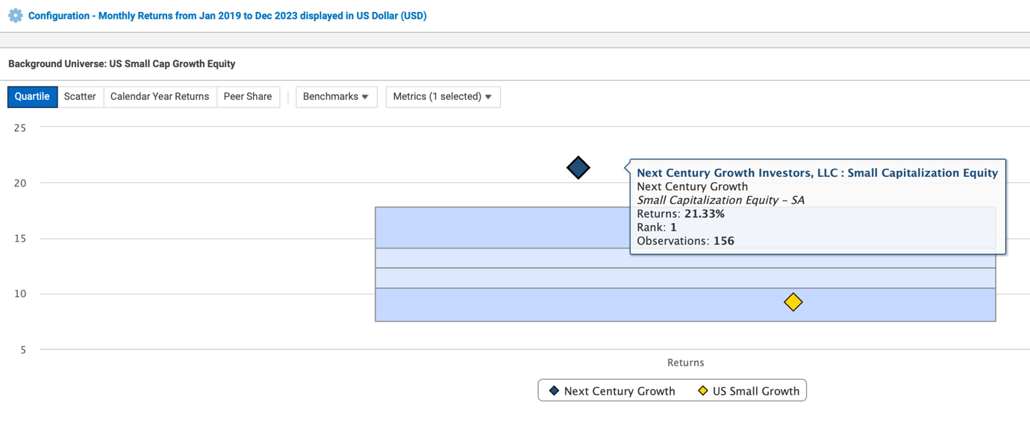
Chairman, CEO, Portfolio Manager and Partner Thomas Press
Bio: Thomas Press of Next Century Growth Investors

Orchard US Small Cap Value Equities
The Orchard US Small Cap Value strategy is a high conviction, high alpha generating strategy that identifies companies that trade at a significant discount to where they should trade at and have one or multiple catalyst to unleash this intrinsic value. A daily liquid Art. 8 UCITS fund with an AUM of USD 312 million (one of the largest in its category) is available. ISIN code: IE00BL0L0092
As per Q4, 2023 the Orchard US Small Cap Value Equity strategy has an annualized outperformance of 2.07% over the Russell 2000 Value index since inception in 2001. Orchard Capital Management is a research-driven value investment manager solely focused on small cap value investing. As an independent employee owned boutique based in Chicago they deliver superior returns through proprietary research and a disciplined process. Long term US small cap value is the best performing segment of US Equities.
- Asset Class & Strategy Summary
- Presentation
- Peer comparison
- Factsheet
- Standard RfP
- Morningstar
- Orchard's approach to ESG
- Sustainability Related Disclosures
- Replay Latest Online Update
Founder and CIO Blake Harper
Bio: Blake Harper of Orchard Capital Management

Best regards,
Martijn van Vliet
Director Business Development Candoris
T +31(0)707441393
M +31(0)637009338
E martijn@candoris.nl
Koninginnegracht 46
2514AD The Hague
The Netherlands
Candoris Strategies: www.candoris.nl
"This email is to be reviewed by only the intended recipient and may contain information that is privileged and/or confidential. If you are not the intended recipient, you are hereby notified that any review, use, dissemination, disclosure or copying of this email and its attachments, if any, is strictly prohibited. If you have received this email in error, please immediately notify the sender by return email and delete this email from your system. Information on a fund offered by Candoris is to be considered as Marketing Communication."
Unsubscribe

