We're in one of the longest periods of US Small Cap underperformance.
History indicates a long period of strong outperformance typically follows, see red arrow.
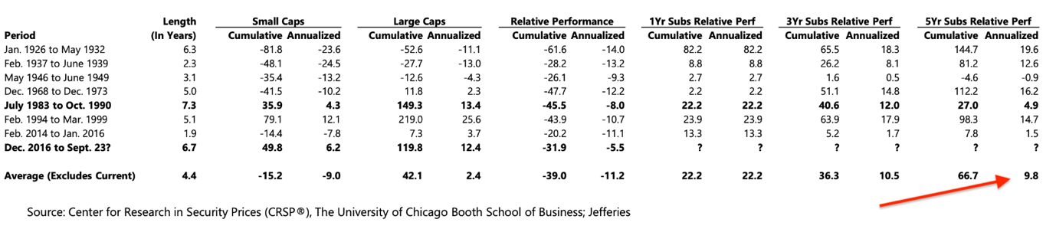
​​​​​​

Performance after first Fed interest rate cut​​
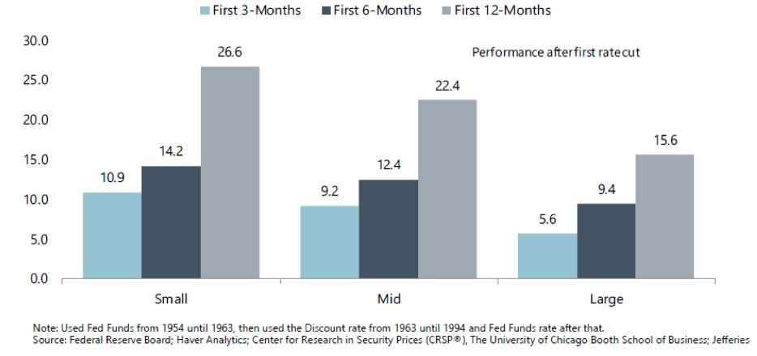

If the public markets don't re-rate Small Cap Stocks,..then the Private markets surely will!
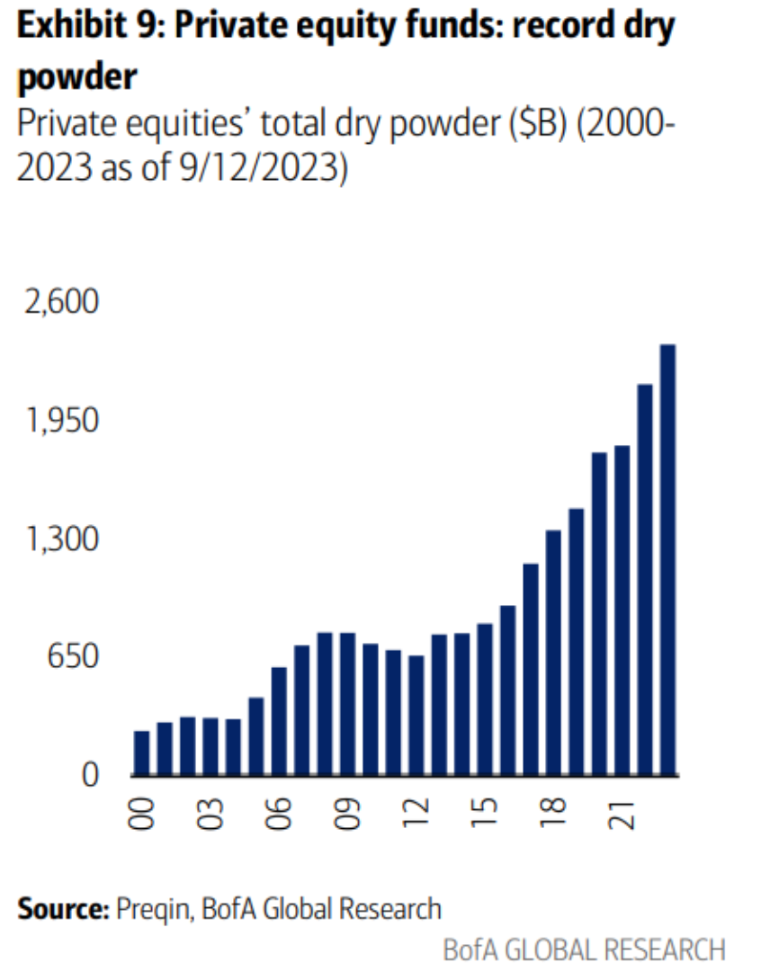

US Small Cap forward P/E is below long term averages and well below that of US Large Cap Equities
Historically this is the other way round.
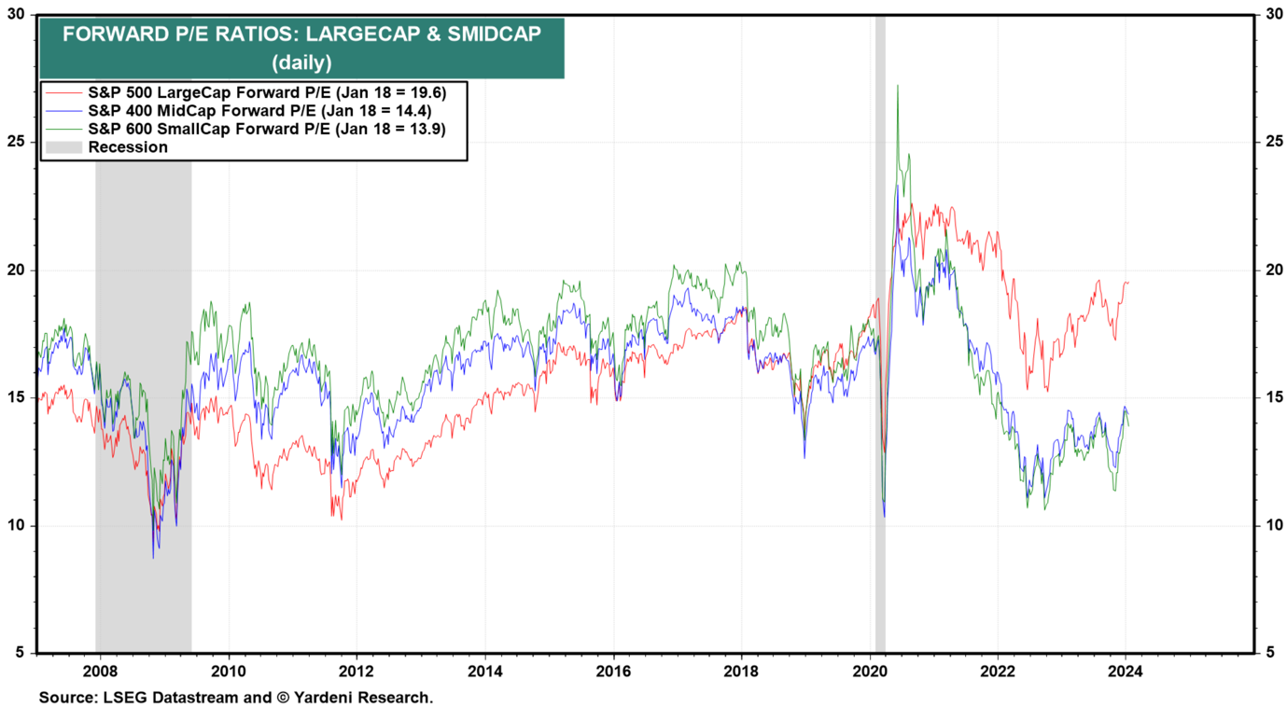

Relative Valuation and Relative Performance of Russell 2000 vs Russell 1000, were at extreme levels.

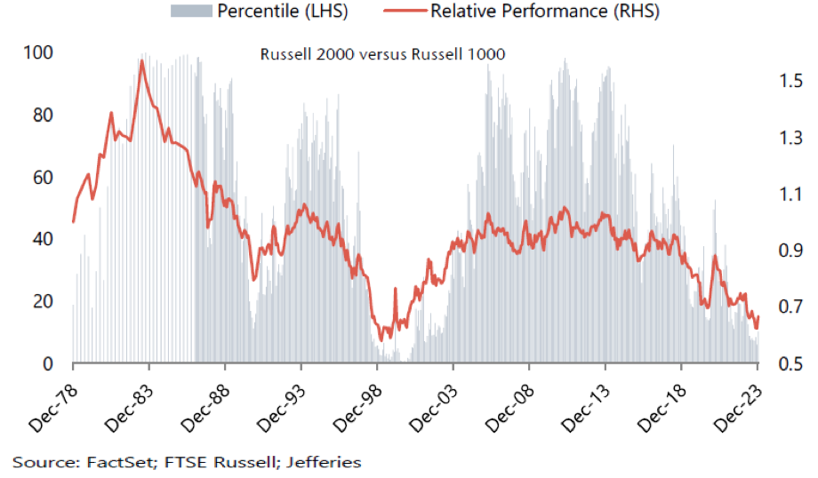

Rolling 5-year Relative Performance of Russell 2000 vs Russell 1000
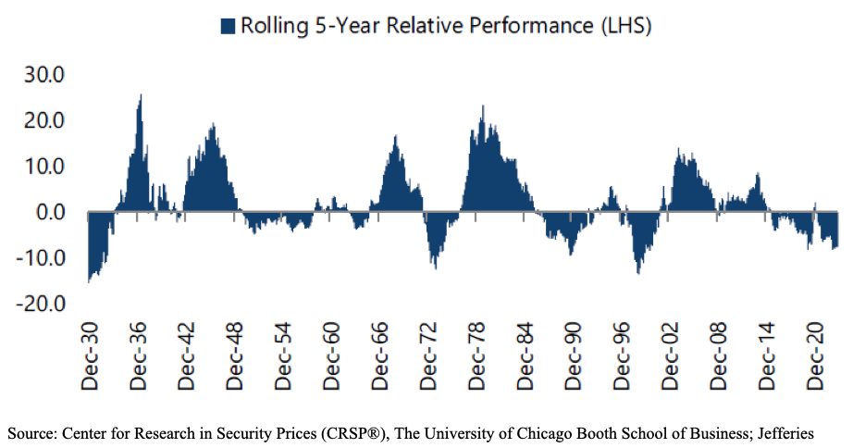

10y return US Large Cap (R1000) versus US Small Cap (R2000)
Large Caps outperformed Small Caps with > 100%.
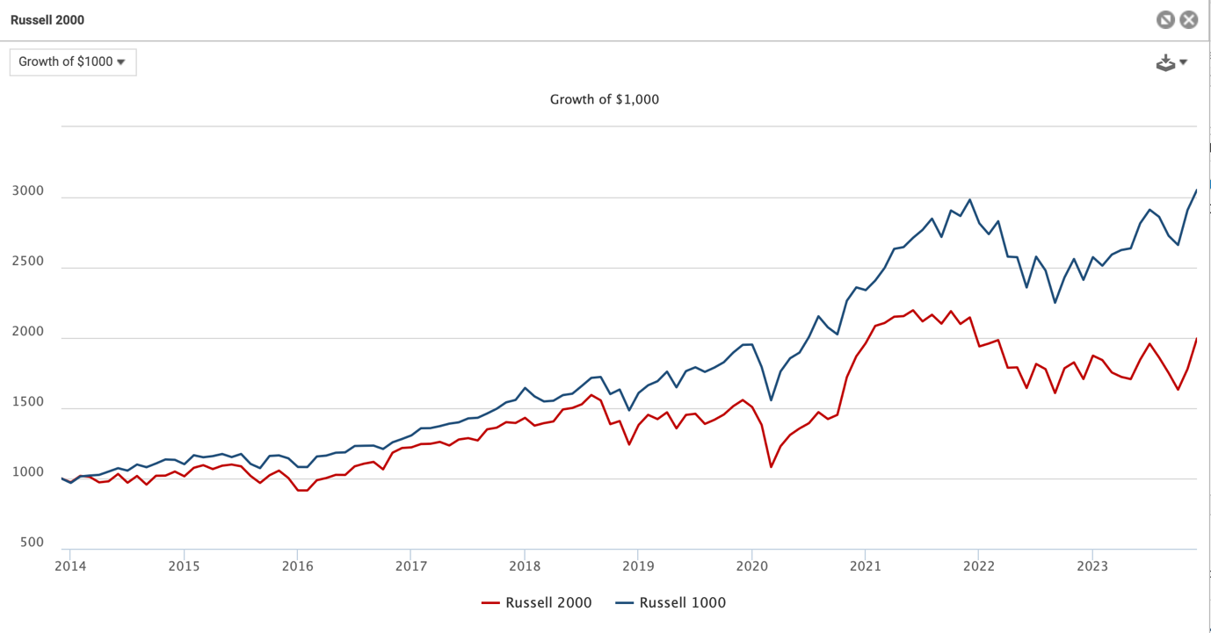

Relative Forward P/E Russell 2000 vs Russell 1000 - 1985-31-10-2023
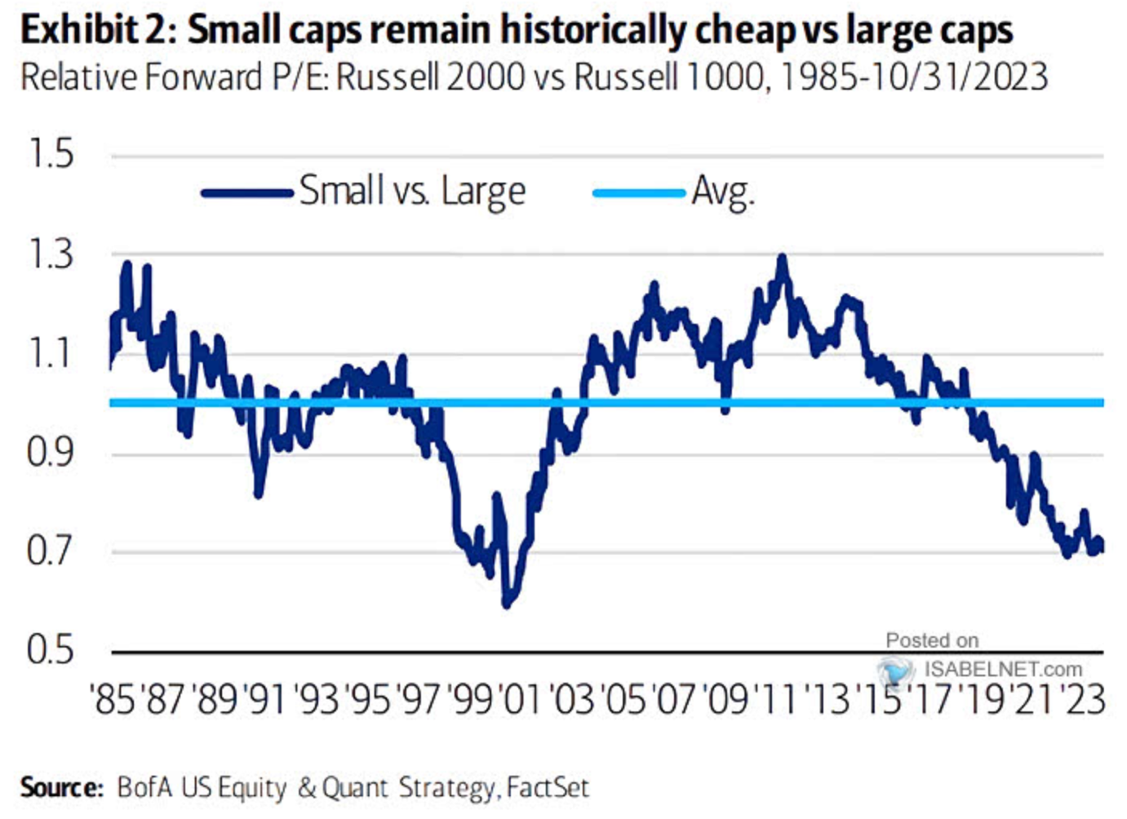

Small Caps/ Nasdaq
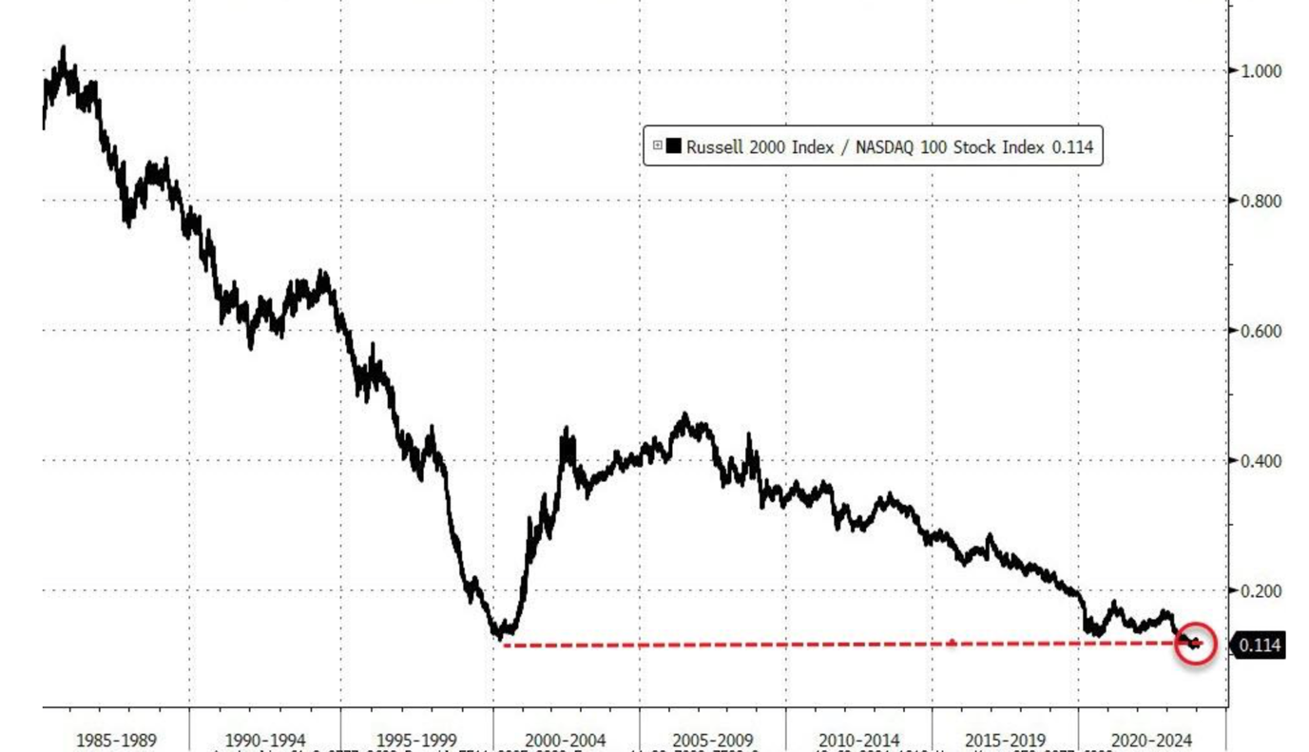

Performance in weaker USD environment
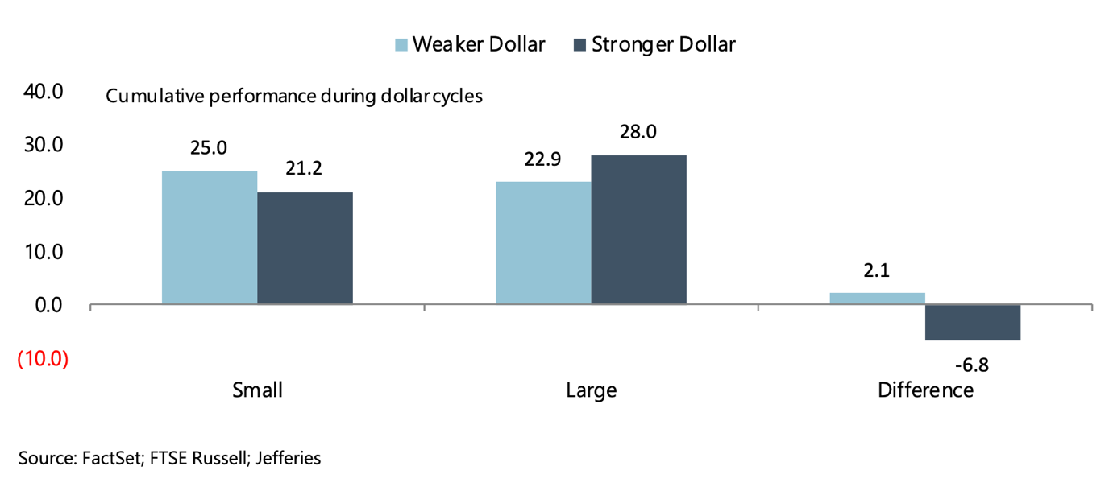

Performance across CPI environments
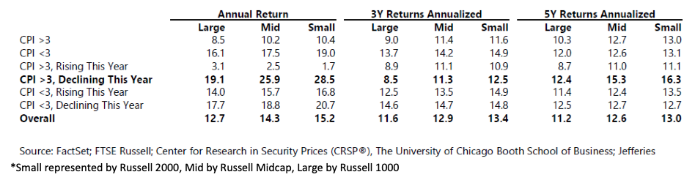

Small Cap Performance Around Recessions (last 6 recessions since 1980)
​​​​​
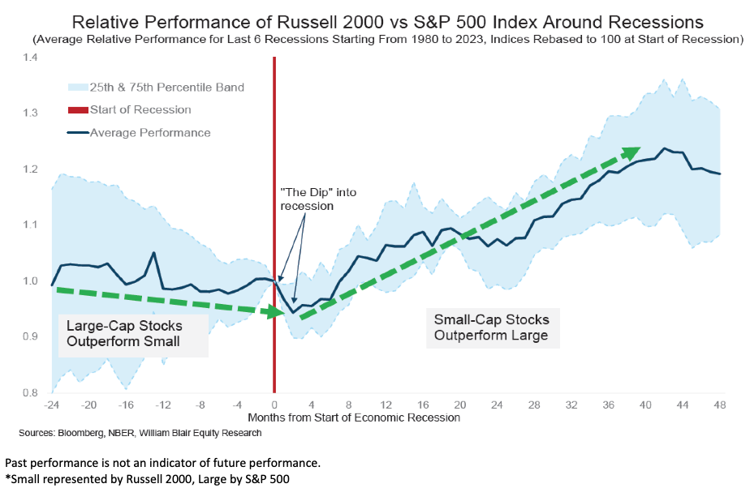

Earnings have corrected:
2023 and 2024 Earnings Growth Estimates (as of 12/28/2023)
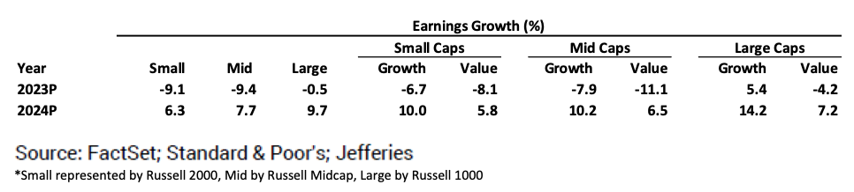

Trends in 2024 Earnings Growth Estimates
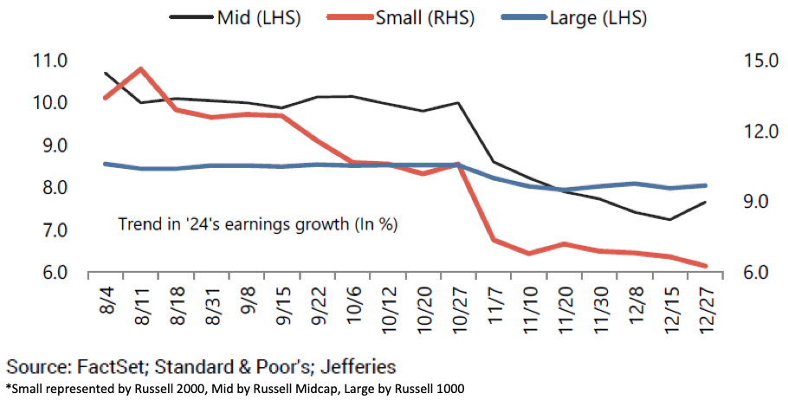

Other related charts:
Expected returns next decade for Magnificent 7 do not look good at all.
Time to sell those and buy things that are cheap?
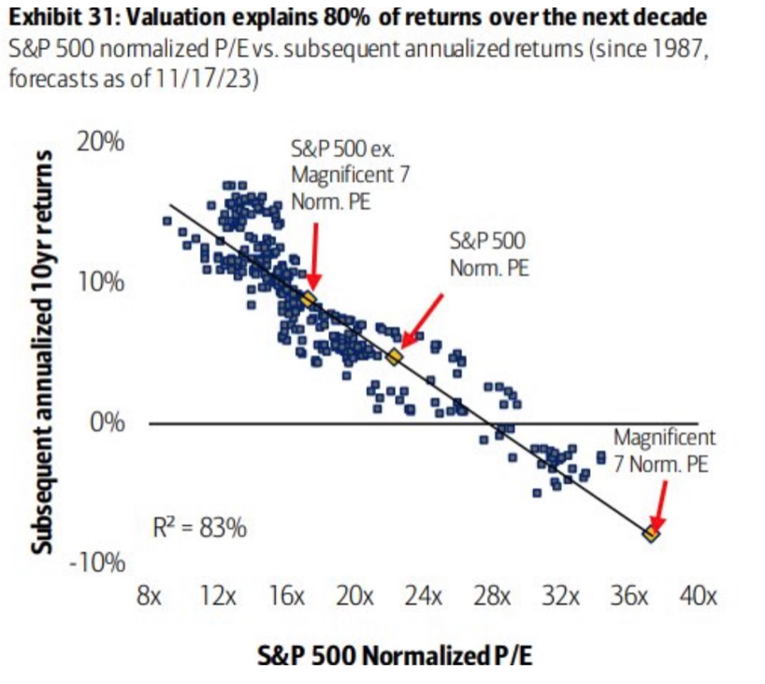

Small Caps have pushed out financing needs, but are typically financed shorter term- have a higher rate sensitivity
One of the reasons small caps tend to do well in FED easing periods
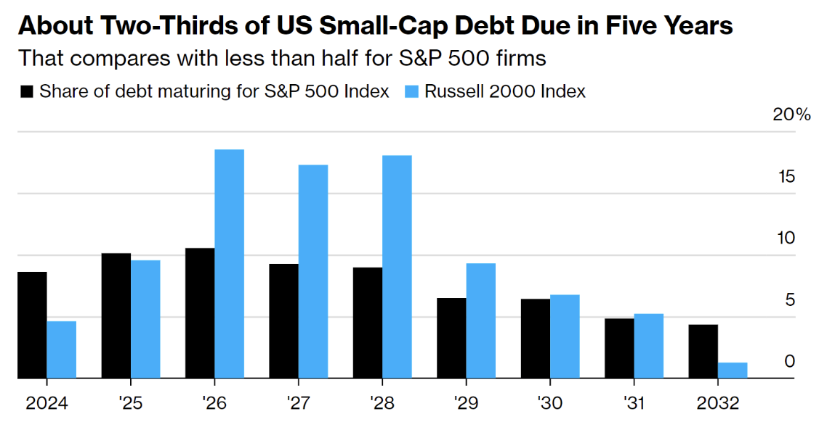

US Small Cap Value worst performer last decade

Last time valuation of Nasdaq versus Small Cap Value got this extreme, this is what happened next...
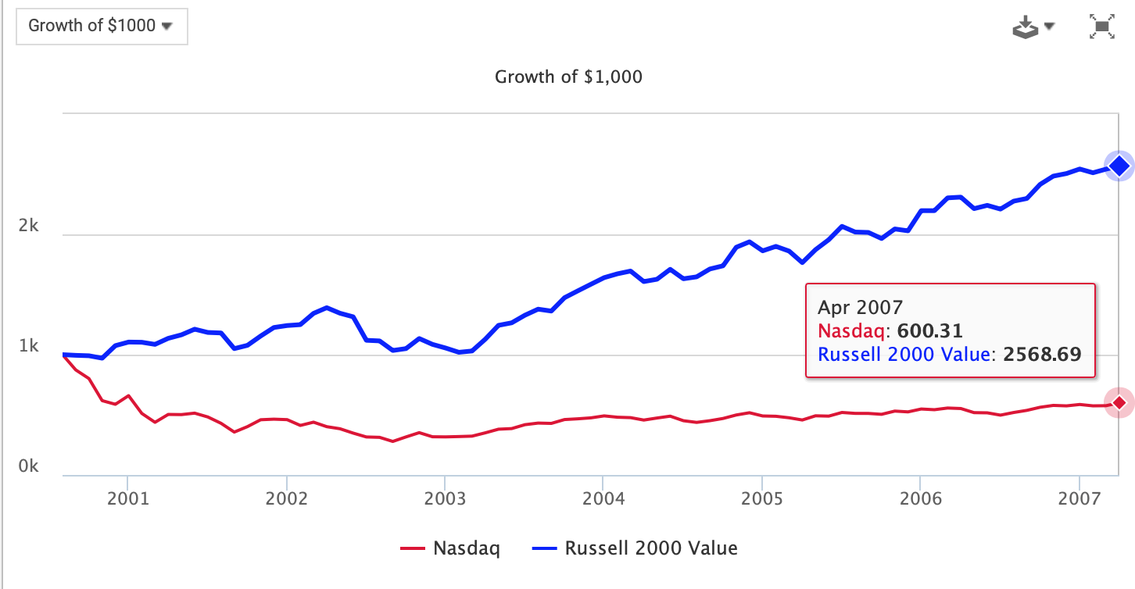
Nasdaq down 40%, Small value up 157%, despite rising rates from 2005-2007

Sales per employee in US Small Caps hit record highs..
​​​​​​
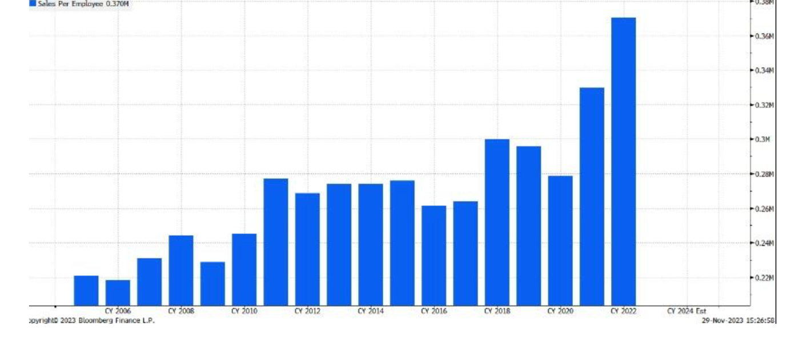

Allocate to active!
Almost all active managers beat the Small Cap Benchmark ( red square) longer term (22 year chart)
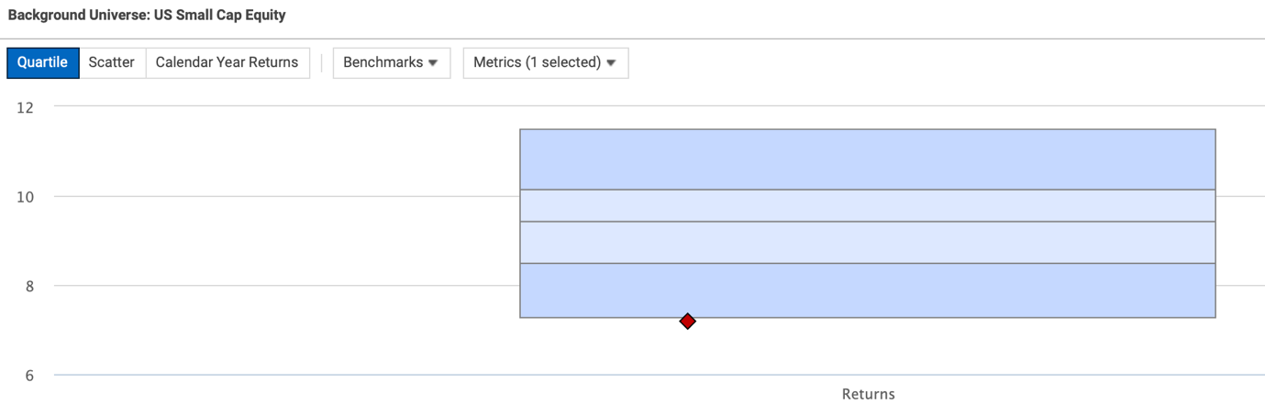

Lack of IPO's and impact of Private Equity on US Small Caps; Is the Small Cap Premium still there??
1) Does the Small Cap premium still exist?
Orchard:
The simple answer is yes, but the longer answer is more nuanced and I'll try to provide an answer as to why we have confidence. The SC premium is a returns premium. The returns premium has occurred partly because smaller companies tend to grow and grow earnings faster over the long run. Over the long run small caps have outperformed and they have outperformed primarily due to cash returns to shareholders (either in dividends or buybacks) rather than valuation (even a 50% increase valuation has a modest impact on the long term composition of returns). However, this total shareholder return (TSR) has been below large caps for some time (13 years), which has driven the lack of a Small Cap premium.
The question is why and is the trend likely to continue. The answer is that the trend should end or reverse because current underperformance is valuation and not earnings growth driven. Earnings have grown nicely, capital allocation has generally improved and relative valuations are unlikely to get worse (or more likely will get better). We have a much more detailed break-down coming in one of our future write-ups, but the reason for our confidence is twofold: a) True Small Cap universe earnings have grown over the same time while valuation shrank and b) Small companies are getting higher valuations, but not in the US public market (yet):
a) Aggregate earnings per share for the Russell 2000 grew annualized 8.2% (157%) from 2010-2022 while valuation shrank (even after accounting for unprofitable companies in the universe). Other areas of the US equity market saw their multiples expand substantially over the same period.
b) While valuation shrank in the public markets, valuation in Private equity for similar companies has growth substantially over a similar period. The most important (though not only) difference between the two markets (relative investor flows were very positive in one and very negative in the other)
We see a disconnect in that large is relatively more valuable for the same earnings and private is relatively more valuable for the same size. With earnings (and the effective use of the earnings to grow or return cash) as the primary long term driver of TSR, we see the premium as quite safe and the likelihood of a further shift in further relative mispricing as substantially lower. Should the disconnect persist in the public market, the private equity market is now of a size that it can acquire more cheaply in the public market than in the private market, which will support public small cap valuations through acquisition premiums.
Next Century Growth:
It currently does not. Due to relative underperformance by small caps over the past few years, US large caps actually trade at a premium despite their slower growth rates. Historically, this is an unusual occurrence that does not sustain for long. Entering 2024, small cap valuations v. large caps were at the 10th percentile on a historical basis (0 being cheapest and 100 being most expensive). Our guess is small caps will begin to outperform even if the economy slows and the market is choppy this year, and will rally on an absolute and relative basis when the economy accelerates.

2) How do you Small Cap investors view the development that small caps are going public later and later? and going first to PE before going public?
Orchard:
This is a phenomenon that has been occurring on some level over the last 20 years, but especially over the last 10 years. It has several implications and I divide it between Tech/Software and "Everything Else." The division between the two is largely because the trend materially impacts the Software and Technology universe while all other categories have operated more normally. The Private Equity industry has bought and IPO'd companies outside of Tech/Software at a fairly normal rate. There has been net consolidation since 2000 (so more acquisitions than IPOs), but industrials, consumer and other industries have a regular amount of activity.
Generally speaking, the trend has been that private equity investment dollars have grown even faster than private equity investments, creating record "dry powder" (see below) and more demand for all companies (public or private), pushing up private valuations. This has the effect of making the same sized public companies more attractive on valuation, likely increasing the probability of further consolidation (and future acquisition/acquisition premiums for small cap owners). This area is where most of small cap value resides. We will have a more detailed review of this in the coming months as part of our series, by the way. The trend in Software/Tech is truly a little different. Whereas in the 90s, many small tech companies would use an IPO as an opportunity for liquidity or growth capital, going public at $200M-$2B market caps, the trend has been that they do an additional 1-3 rounds of private financing and exit at $2-10B. This is partly because Growth Private Equity as an asset class has grown massively and because successful software companies have much larger markets and lower fixed cost of investment (driving earlier cash flow visibility). The "hassle" of being public for those companies is deferred. Many of these companies entirely miss the small cap market and when they do, they are going at very high valuations.
Generally, we have always been sensitive to valuations of these companies (as the winners are huge wins but there are far more losers in the long run) and we have focused on tech and software niches or the very few that drop back into our category but that have defensible and attractive long-term prospects. You will see that we are underweight tech partly for this reason. However, we have found technology leadership hiding in payments (found in financials and consumer), in fintech, in consumer (adtech and machine-learning and AI-driven online retail), and in real-estate (edge computing data centers) where the same secular trends are driving outsize growth and profitability. You just need to dig a bit more to find them. We are also lucky in that while many of the leading tech names miss our sector now, the remaining overpriced ones tend to sit in mid-cap growth (and a few at the edges of small cap growth), whereas we typically are playing in small value and mispriced small core areas. I'm happy to provide examples because we still have a rich universe of "new economy beneficiaries" in our opportunities set.
Next Century Growth:
Historically small caps have had venture capital or PE funding prior to IPO, so that’s not a big change. It’s true that some have elected to stay private longer or indefinitely and do more PE funding. We believe this is cyclical and was driven by a flood of money into PE firms over the past several years. It created a situation where more companies had access to PE funding and at more favorable (some would say aggressive) valuations than in the past. Our view is this is leading to suboptimal returns for the PE fund investors which will lead to a contraction of available funds, making the IPO route relatively more attractive and the pendulum will swing back in the future. Our sense is that PE investment returns peaked in 2021 and have been plummeting since then, but on a lag to the real time mark-to-market you get in public equities. We expect the volume of high quality small cap IPOs will be increasing over the coming years.

Upcoming Online Updates in which the topics above will be discussed:
- 30 January at 15.00 CET, Letko Brosseau Emerging Markets Equity Update
- 1 February at 16.00 CET, Strategic income Management US High Yield Opportunities Update
- 6 February at 15.00 CET, Orchard US Small Cap Value Equities Update
- 5 March at 15.00 CET, Next Century Growth US Small Cap Growth Equities Update
- 19 March at 15.00 CET, VanEck Emerging Market Debt Update
- 21 March at 16.00 CET, DSM US and Global Large Cap Growth Update
- 18 April at 15.00 CET, Coho ESG US Large Cap Equities Update
Click here for the replay of the Candoris online Macro outlook event.

Why US Small Cap Value and Growth and not Core?
1) Long term return data shows that US Small Cap Growth + US Small Cap Value managers perform better than US Small Cap Core managers.
2) Yearly rebalancing between Value and Growth adds value and reduces volatility.
When you look at for example the last 10 years, NCG US Small Cap Growth returned +12.35% annualized, Orchard US Small Cap Value returned +6.71% (growth did better than value). Together without rebalancing, this is 19.06%/2= 9.53%. With yearly rebalancing you get to 10.19%, so 0.66% annualized more due to rebalancing yearly on January 1st.
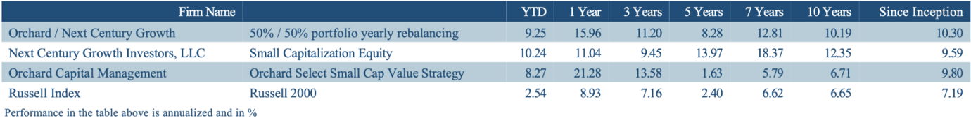
All data is gross of fee.

Long term performance Orchard, NCG and the combined portfolio with yearly rebalancing vs benchmark
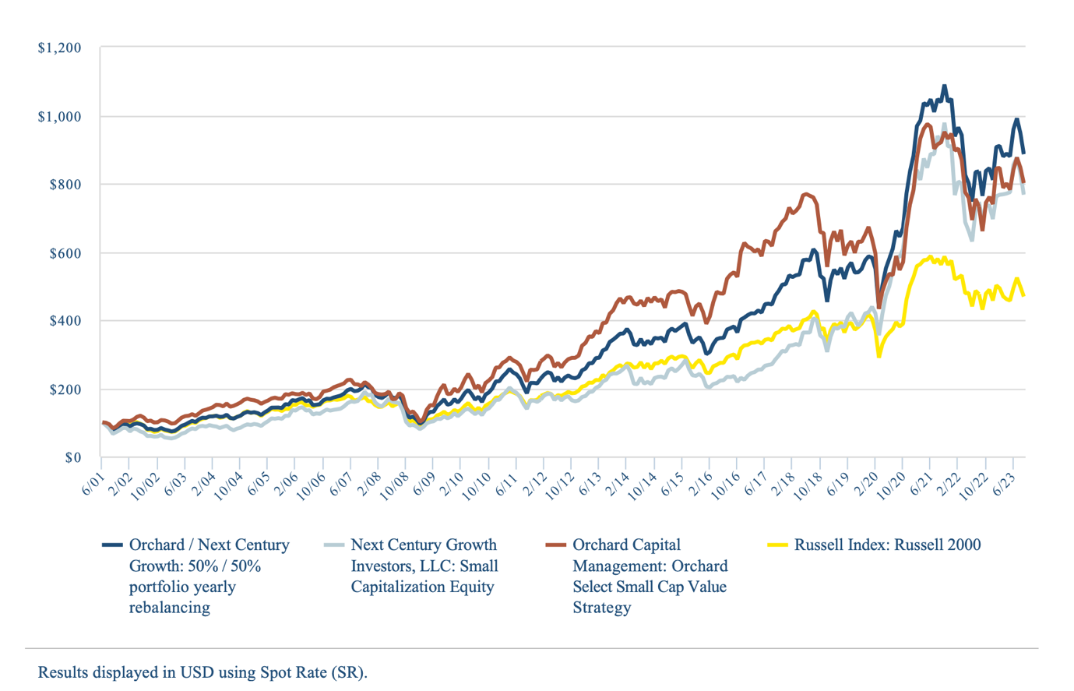

Next Century Growth US Small Cap Growth Equities
The Next Century Growth (NCG) US Small Cap Growth Strategy is a high conviction, high alpha generating strategy that seeks to invest in the fastest growing and highest quality small cap companies in America. A daily liquid Art. 8 UCITS fund with an AUM of USD 61 million is available. ISIN code: IE000TY23GV5
As per Q4, 2023 the Next Century Growth US Small Cap Growth Equity Strategy has an annualised outperformance of 5.01% over the Russell 2000 Growth index, outperforming 83% of peers according to eVestment since inception in 1999. Next Century Growth is an independent investment firm with a highly experienced investment team located in Minneapolis.
- Asset Class & Strategy Summary
- Presentation
- Peer comparison
- Factsheet
- Standard RfP
- Morningstar
- ESG Policy
- Sustainability Related Disclosures
- Replay Latest Online Update
Next Century Growth strategy beats all US Small Cap Growth peers on a 5 year basis
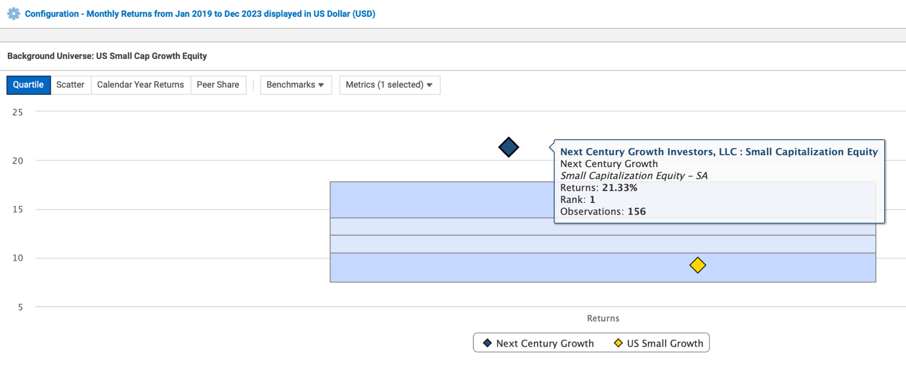
Chairman, CEO, Portfolio Manager and Partner Thomas Press
Bio: Thomas Press of Next Century Growth Investors

Orchard US Small Cap Value Equities
The Orchard US Small Cap Value strategy is a high conviction, high alpha generating strategy that identifies companies that trade at a significant discount to where they should trade at and have one or multiple catalyst to unleash this intrinsic value. A daily liquid Art. 8 UCITS fund with an AUM of USD 312 million (one of the largest in its category) is available. ISIN code: IE00BL0L0092
As per Q4, 2023 the Orchard US Small Cap Value Equity strategy has an annualized outperformance of 2.07% over the Russell 2000 Value index since inception in 2001. Orchard Capital Management is a research-driven value investment manager solely focused on small cap value investing. As an independent employee owned boutique based in Chicago they deliver superior returns through proprietary research and a disciplined process. Long term US small cap value is the best performing segment of US Equities.
- Asset Class & Strategy Summary
- Presentation
- Peer comparison
- Factsheet
- Standard RfP
- Morningstar
- Orchard's approach to ESG
- Sustainability Related Disclosures
- Replay Latest Online Update
Founder and CIO Blake Harper
Bio: Blake Harper of Orchard Capital Management

Best regards,
Martijn van Vliet
Director Business Development Candoris
T +31(0)707441393
M +31(0)637009338
E martijn@candoris.nl
Koninginnegracht 46
2514AD The Hague
The Netherlands
Candoris Strategies: www.candoris.nl
"This email is to be reviewed by only the intended recipient and may contain information that is privileged and/or confidential. If you are not the intended recipient, you are hereby notified that any review, use, dissemination, disclosure or copying of this email and its attachments, if any, is strictly prohibited. If you have received this email in error, please immediately notify the sender by return email and delete this email from your system. Information on a fund offered by Candoris is to be considered as Marketing Communication."

